**St Andrew’s Dancers Frosted Fling**

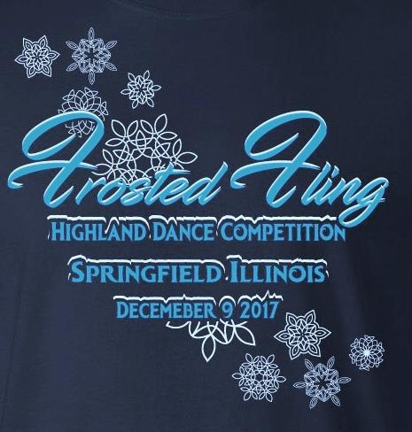



**Saturday, December 1st 2018**

**Elliot Baptist Church**

**501 W Elliot Ave, Springfield Il 62702**

DANCE REGISTRATION

**Dance Schedule of Events**

8:30 All Dancers registration

9:00 All Dancers Competition Begins

Competition begins with the primary pas de bas and pas de bas and high cuts, and goes through national for ALL Beginner, Novice, Intermediate and Premier. Then primary fling and goes through all categories fling,then beginners,novice,intermediate and premier go through all Sword and same with ALL Sean Triubhas'.

**Events** (Dances are subject to change):

**Premier (Under 12)**

17.Blue Bonnets

18 .Highland Fling (4)

19. Sword Dance (2 & 1)

20. Seann Triubhas (3 & 1)

**Premier (15 & Under)**

21. Blue Bonnets

22. Highland Fling (6)

23. Sword Dance (3 & 1)

24. Seann Triubhas (4 & 2)

**Premier (16 & Over)**

25. Blue Bonnets

26. Highland Fling (6)

27. Sword Dance (3 & 1)

28. Seann Triubhas (4 & 2)

**Primary Dancers 6 yrs & under**



1. 16 pas de basques

2. pas de basques & highcuts

3. Highland Fling (4)

4. Sword Dance (2 & 1)

**Beginner**

5. Lilt (4)

6. Highland Fling (4)

7. Sword Dance (2 & 1)

8. Seann Triubhas (3 & 1)

**Novice**

9. Flora (4)

10. Highland Fling (4)

11. Sword Dance (2 & 1)

12. Seann Triubhas (3 & 1)

**Intermediate**

13. Barracks

14. Highland Fling (4)

15. Sword Dance (2&1)

16. Seann Triubhas (3&1)

**FUSTA MW 14 HIGHLAND DANCE COMPETITION RULES**

All judge’s decisions are final. Dancers may compete in one section only. Age applies as of December 1, 2018. Proof of age must be furnished if requested. All dancers must present a registration card to compete. If you do not have one, contact your appropriate FUSTA representative. Any competitor not ready to perform when their number is called will be disqualified for that dance. No medals will be worn during competition. Competitors will remain in costume until all medals and trophies have been awarded. No entry will be accepted unless accompanied by remittance. Dancers entering the competition first will dance last. Age groups will be determined according to number of entries. **Medals will be awarded in all categories except PREMIER 16 & OVER, where cash will be awarded.** A trophy will be awarded to the highest point winner in each age group above primary.

St. Andrew’s Society of Central Illinois reserves the right to add or remove events from the schedule and to make other changes as long as its action is within the scope of the Scottish Official Board of Highland Dancing rules and, in the judgment of the committee, is in the best interest of the competition.



I have read and understand the rules and regulations listed on this form and wish to be entered in the events I have circled. I hereby, for myself, my heirs and executors, assign, wave and release any and all rights and claims I may have for damages against the St. Andrew’s Society of Central Illinois sponsors, the agents or representatives for any injuries which may be suffered by me attending, participant in, or traveling to and from said dance competitions.

**________________________________________________________________________**

*Competitor’s signature (parent/guardian if less than 18 years) (one entry form per participant)*

**DANCER NAME** (print)**_______________________________________________________**

**ADDRESS_________________________________________________________________________________________**

**CITY, STATE, ZIP______________________________________________________________________________________**

**PHONE & EMAIL___________________________________t-shirt size (included in entry)__________________________**

**AGE________ DATE OF BIRTH______________________ FUSTA NUMBER______________________________________ Category and Dances participating in ____________________________________________________________________**

**TEACHER’S SIGNATURE REQUIRED______________________________________________________________________**

**Return completed entry form to: Beth Ogilvy, 5499 Old Jacksonville Rd Springfield, IL 62711**

**Email:** bethogilvy@comcast.net **Entry Fees: Pre-Premier $30 Premier $35 ($5 fee goes to FUSTA)**

***ENTRY DEADLINE: Entry must be received by November 24th 2018. If postmarked after November 24th2018, please attach a $10.00 late fee. Make checks payable to: St Andrew’s Dancers***



***Additional t-shirts - reserve and pick up that day $15_______________________________________________***

**St Andrews Dancers presents…..… The Frosted Fling ……… December 1st, 2018**

**Elliot Baptist Church**

**501 W Elliot Ave, Springfield Il 62702**

**General Admission - $5**

|  |  |  |  |
| --- | --- | --- | --- |
| **Dance Competition Sponsor** | | | |
| **Primary sponsor** | **Gets 2 adults sponsor seating** | | **$20** |
| **Beginner sponsor** | **Plus name in the program** | | **$30** |
| **Novice sponsor** | **Plus t-shirts** | | **$50** |
| **Intermediate sponsor** | **Plus snack bar voucher** | | **$100** |
| **Premier sponsor** | **Plus name on a trophy** | | **$150** |
|  |  | |  |
| **Names:** | | | |
| **1)** | | | |
| **2)** | | | |
| **Email phone** | | | |
| **address** | | | |
| **Make tax deductible check to St. Andrew’s Dancers** | | | |
|  | | **Amount enclosed $** |  |